**Lab-5**

Name: Dishant Modh

Roll No.: IT076

# Aim:- **WAP to study Using arithmetic operators in Prolog.**

# **• Accept name of the student, rollno, his subject name, maximum marks and obtained marks in the subject. (Take marks of at least 6 subjects). Compute the percentage of a student. Display his result with other information. Use variables, arithmetic operators, I/O predicates appropriately.**

**1. Code:-**

domains

predicates

go

clauses

go:-

write("Enter name of student:-"),readln(N),nl,

write("Enter roll number of student:-"),readint(RN),nl,

write("Enter subject information for 6 subjects:-"),nl,

write("Subject1 name:-"),readln(S1),nl,

write("Max marks for subject1:-"),readint(MM1),nl,

write("Obtain marks:-"),readint(M1),nl,

write("Subject2 name:-"),readln(S2),nl,

write("Max marks for subject2:-"),readint(MM2),nl,

write("Obtain marks:-"),readint(M2),nl,

write("Subject3 name:-"),readln(S3),nl,

write("Max marks for subject3:-"),readint(MM3),nl,

write("Obtain marks:-"),readint(M3),nl,

write("Subject4 name:-"),readln(S4),nl,

write("Max marks for subject4:-"),readint(MM4),nl,

write("Obtain marks:-"),readint(M4),nl,

write("Subject5 name:-"),readln(S5),nl,

write("Max marks for subject5:-"),readint(MM5),nl,

write("Obtain marks:-"),readint(M5),nl,

write("Subject6 name:-"),readln(S6),nl,

write("Max marks for subject6:-"),readint(MM6),nl,

write("Obtain marks:-"),readint(M6),nl,

OOM = M1 + M2 + M3 + M4 + M5 + M6,

MMM=MM1+MM2+MM3+MM4+MM5+MM6,

PRR=OOM/MMM*100,

write("**********RESULT**********"),nl,

write("Student name:-"),write(N),nl,

write("Roll no - "),write(RN),nl,

write("Subject Name- "),write(S1),write(" "),write(S2),write(" "),write(S3),write(" "),write(S4),write(" "),write(S5),write(" "),write(S6),write(" "),nl,

write("Total marks-"),write(MMM),nl,

write("Total obtain marks -"),write(OOM),nl,

write("%Percentage : "),write(PRR).

**2. Output:-**

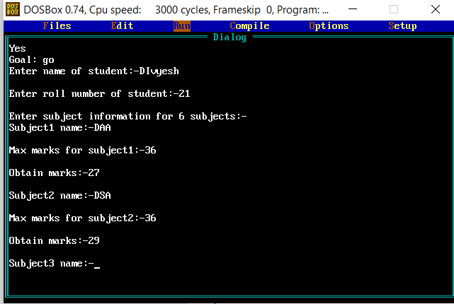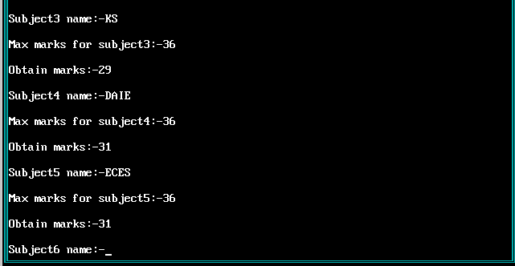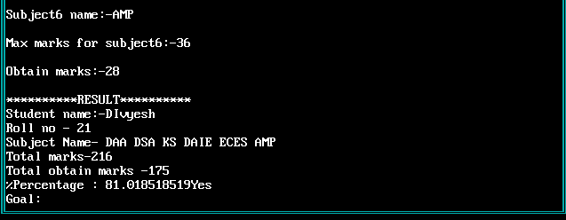

**• Accept department, designation, name, age, basic salary, house rent allowance (HRA) of an employee. Compute dearness allowance (DA) which is 15% of basic salary. Determine the gross salary(BA+HRA+DA) of the employee. Display all information of the employee**

**1. Code**

predicates

go

da(real,real)

gross(real,real,real)

clauses

go:-

write("Enter employee name: "), readln(N),

write("Enter department: "), readln(D),

write("Enter age: "), readint(A),

write("Enter basic salary: "), readreal(S),

write("Enter HRA: "), readreal(H),

write("------PAYSLIP------"), nl,

write("Employee name is: "), write(N), nl,

write("Department: "), write(D), nl,

write("BA: "), write(S), nl,

write("DA: "), da(S,DA), write(DA), nl,

write("Gross salary: "), gross(S,H,G), write(G), nl.

da(S,DA):-

DA=0.15*S.

gross(S,H,G):-

da(S,DA),

G=S+H+DA.

**2. Output**

